Invite External Guest to Meeting

In this guide you will learn how to invite an external guest to a meeting in MS-Teams.
In the Teams client, click on the “Meetings” tab and then on the “schedule a Meeting” button.
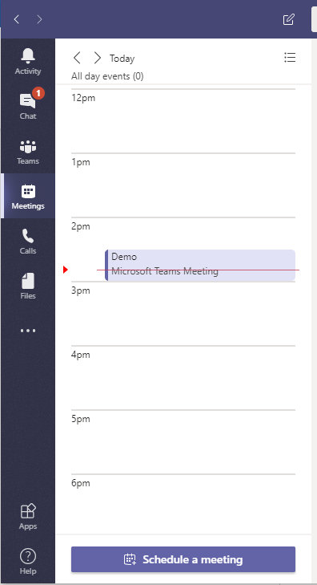

Fill out the meeting details such as Title, Date and location.
once you finished editing the meeting details, simply add the email address of the external guest you want to add under the “Invite people” bar. The username will pop out once you finished entering the email address. Click on pop up to add it to the list.
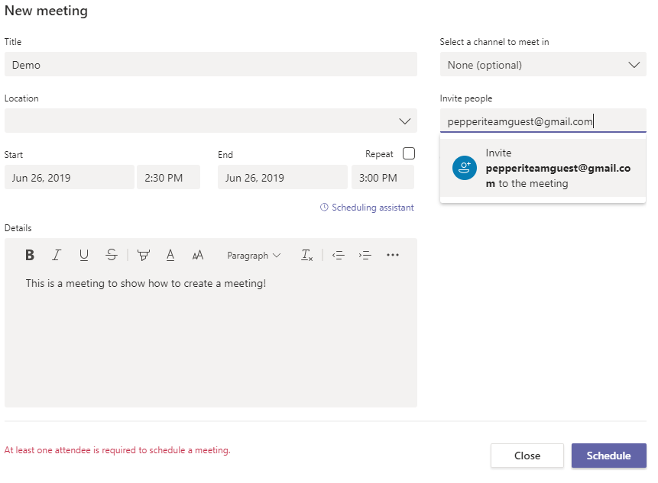
Then click the “Schedule” button.
You should see a summary of the meeting you just created
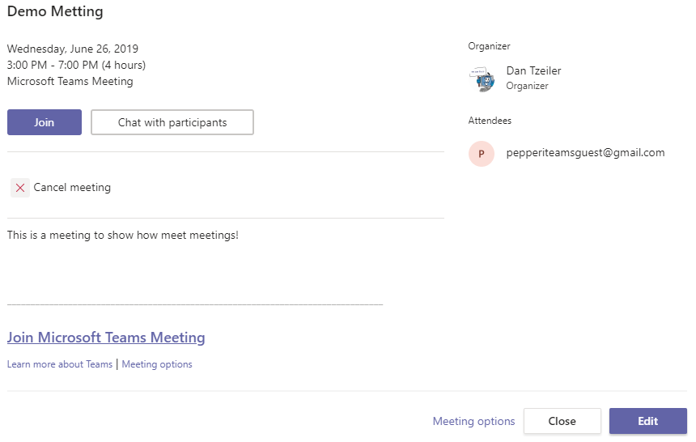
Your guest should receive an e mail invitation that will look like this:
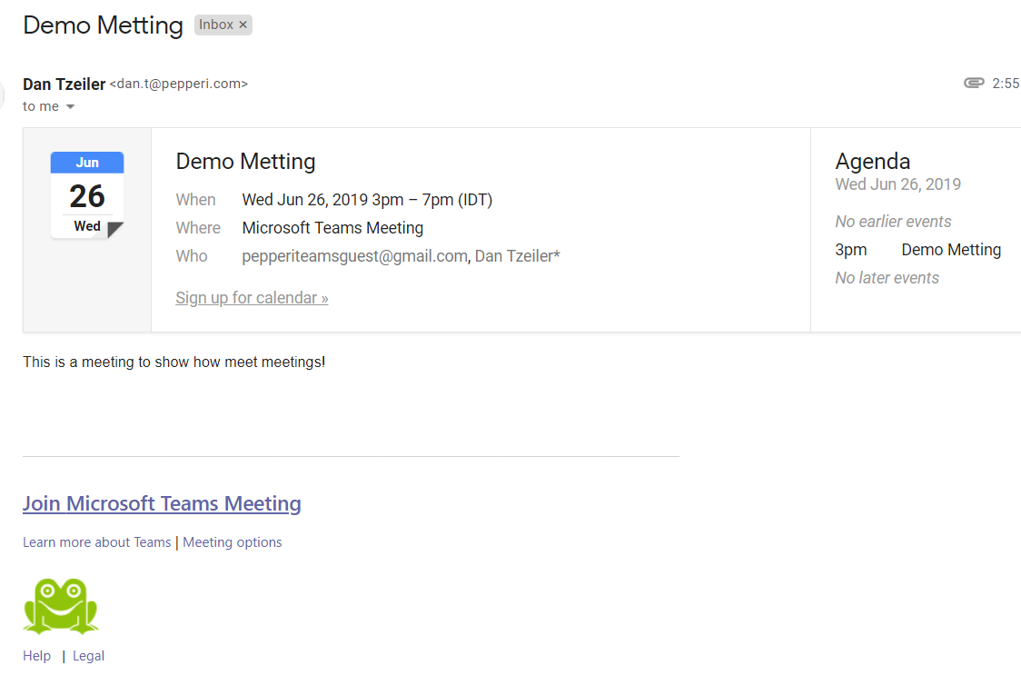
Once the guest clicks on the “Join Microsoft Teams Meeting” he will be able to join the meeting you have invited.
The guest needs to configure his Display Name and audio devices.:
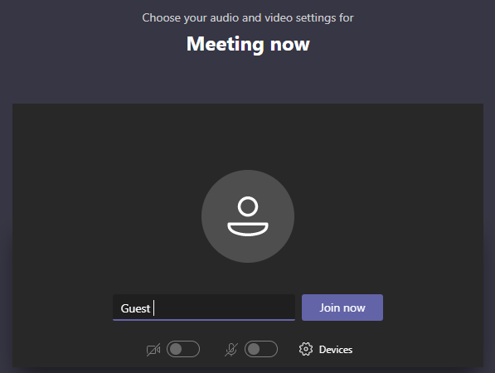
Once the Guest clicks on the “join now” button he will be transferred to the Lobby. The meeting won’t start until the meeting organizer joins in.
The organizer of the meeting will see a pop up to join the meeting also. Once he enters the chat room, he is able to see who is in the lobby and then invite them into the chat:
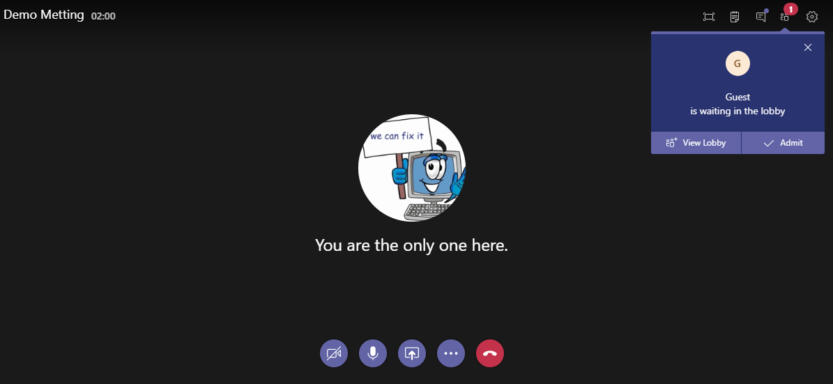

If you encounter any issues with this process, please contact your IT Team

*Metting is definitely a word. You can’t prove otherwise.

